Professional Counseling Experience
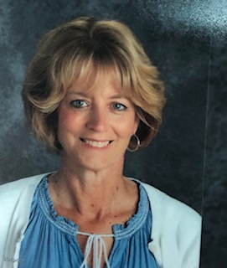

Laurie Smith
  - School CounseloR
Certified K-12
Maryland Advanced Professional Certificate (APC), School Counselor
School Administration I
Pupil Personnel Certification
STUDENTS of all ages need guidance and support, especially when going through academic, social, and personal issues. School counselors act as advocates for the student's well-being, listening to their concerns in a caring, non-judgmental way. There can be various issues that students come to see a school counselor for, such as bullying, depression, relationship troubles, low self-esteem, learning disabilities, poor academic performance, and parental issues (just to name a few).

  - Contact Info:
  - Laurie Smith
  - 101 Prospect Mill Rd.
  - Bel Air, MD 21015
  - T 410.638.3817
  - E Laurie.Smith@hcps.org

School COunselor

SANDLEWOOD Elementary School, Baltimore COunty

1995-2002

School COunselor

Magnolia Middle School, Harford COunty

2006-2015

School COunselor

Prospect Mill Elementary School, Harford COunty

2019- Present

Education
Towson University, Towson, MD
School Administration Certificate

John Hopkins University, Baltimore, MD
Plus 30 Certification in Counseling Youth at Risk

University of Maryland Eastern Shore, MD
Masters in School Counseling K-12

Salisbury University, Salisbury MD
BA Major in Psychology and Communications

What Does a school counselor Do?
- Help students understand and overcome social or behavioral problems through individual and group counseling
- Provide individual and small group counseling based on student needs
- Work with students to develop skills such as organization, time management, and effective study habits
- Develop strategies with teachers, administrators, and parents to help students succeed
- Teach classes on topics such as bullying, drug abuse, and planning for college or careers after graduation
- Refer students and parents to resources outside the school for additional support if needed

